**Title:**

Flu Shot Data Analysis Project using PostgreSQL.

**Requirements:**

You will have a few flat files, load them into PostgreSQL and answer the following important healthcare questions.

**Problem Statements:**

1. **Annual Flu Shot Statistics by Demographics:**
   * How many patients received a flu shot in the year 2022, broken down by age, race, and county?
   * Answer query:

1. **Percentage Analysis of Flu Shots:**
   * What is the percentage of patients who received a flu shot in 2022 compared to the total number of patients, stratified by age, race, and county?
   * Answer query:

* + What is the overall percentage of patients who received a flu shot in 2022 across the entire hospital or clinic?
  + Answer query:

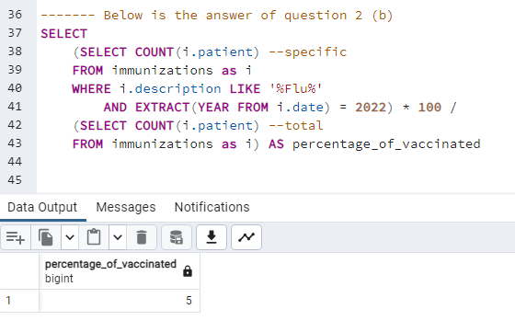

1. **Monthly Cumulative Flu Shot Data:**
   * How many flu shots were administered each month during the year 2022?
   * Answer query:

1. **Total Annual Flu Shots:**
   * What is the total number of flu shots given in the year 2022?
   * Answer query:

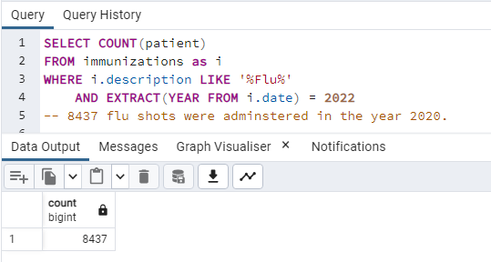

1. **Patient Lists for Flu Shot Analysis:**
   * Can you provide a list of patients who received a flu shot in 2022?
   * Answer query:

* + Can you also provide a list of patients who did not receive a flu shot in 2022?
  + Answer query:

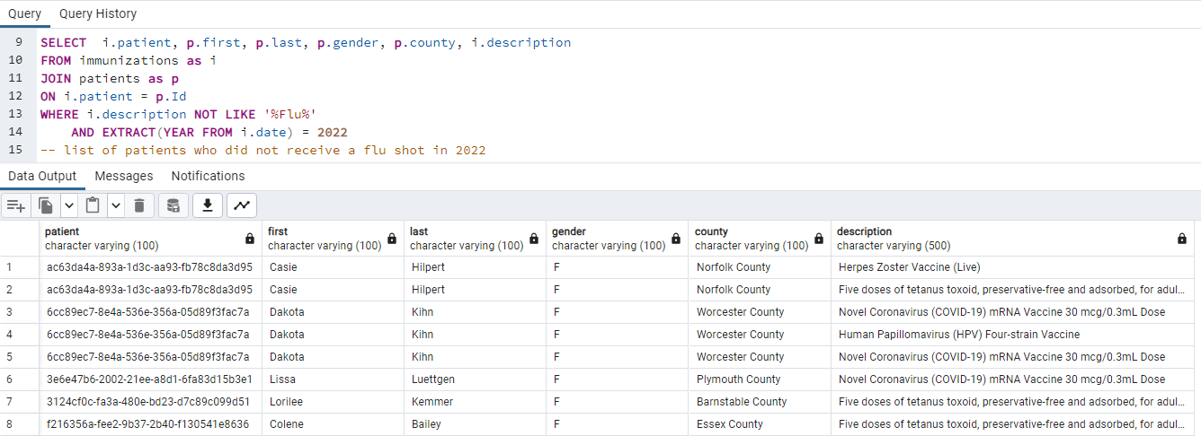

**More Questions that should be answered:**

1. **Patient Demographics Analysis:** How many patients are in each age group (e.g., 0-18, 19-35, 36-60, 60+)?

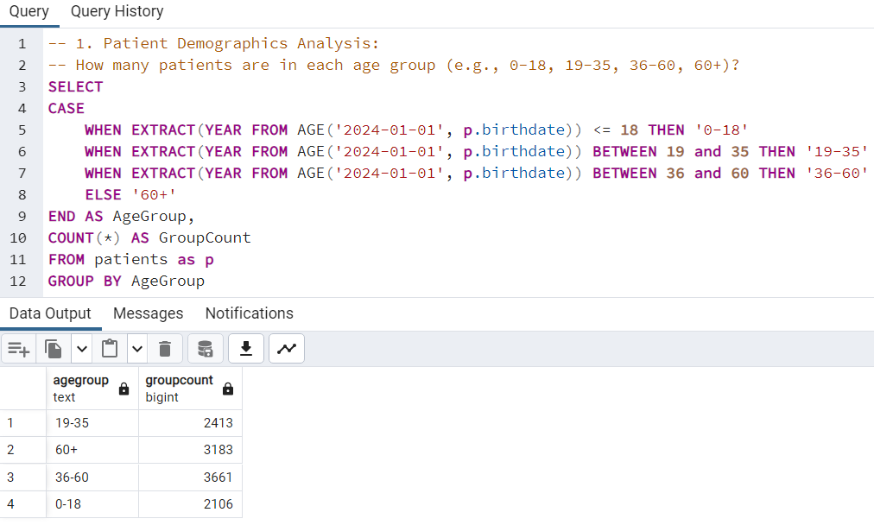

1. **Geographical Distribution:** What are the top 5 cities with the highest number of patients?

1. **Healthcare Utilization Patterns:** How many encounters does each patient have on average?
   1. **There are 2 meanings of the question:** I’ve solved both.
      1. This means that how many encounters does each patient have:A screenshot of a computer

         Description automatically generated
      2. This shows how many encounters does each patient have on average, so the answer will be just one for all patients and not different for each patient: A screenshot of a computer

         Description automatically generated
2. **Condition Prevalence:** What are the top 10 most common conditions among patients?

1. **Healthcare Costs Analysis:** What is the average healthcare expense per patient?

1. **Encounter Analysis:** Which type of encounters (as per **ENCOUNTERCLASS**) is most common?

1. **Income vs. Healthcare Coverage:** Is there a correlation between patients' income levels and their healthcare coverage amounts?

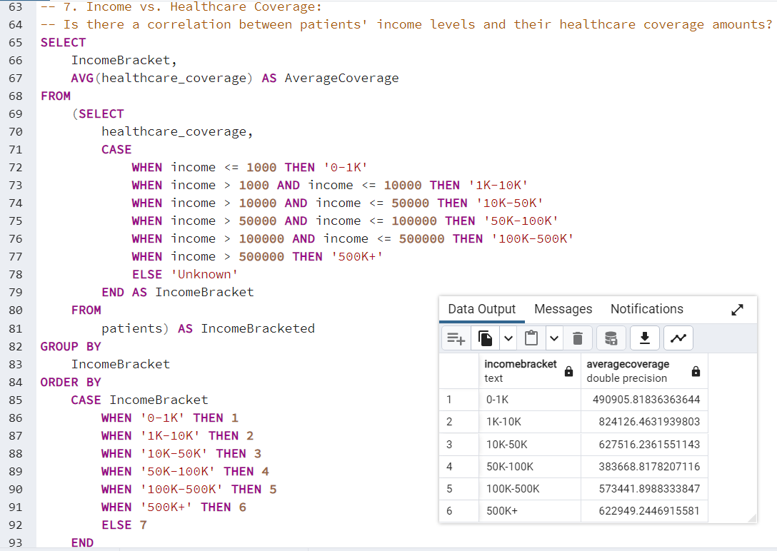

1. **Immunization Records:** How many patients have received each type of immunization?

1. **Patient Mortality:** What is the average age at death for patients, and how does it vary by gender and race?

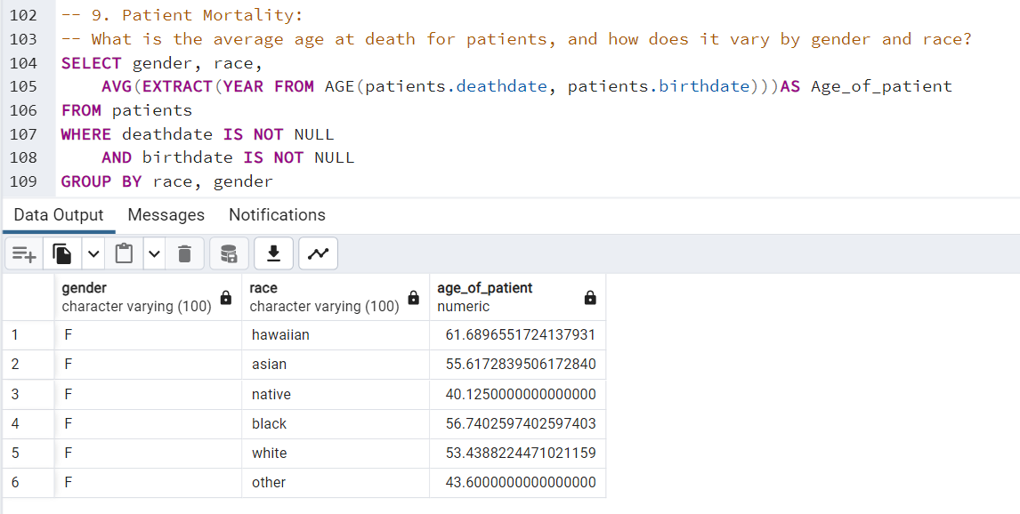

1. **Provider Workload:** Which healthcare provider has attended the most encounters?

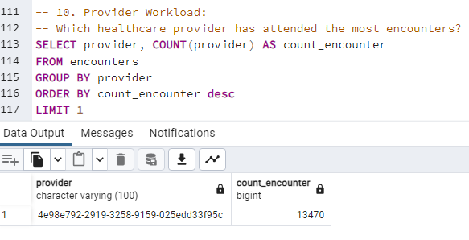

1. **Encounter Costs Analysis:** What are the average total claim costs and payer coverage for each encounter class?

1. **Marital Status and Health:** Is there a notable difference in the number of healthcare encounters between married and single patients?

1. **Race and Ethnicity in Healthcare:** How do healthcare expenses vary across different races and ethnicities?

1. **Chronic Condition Management:** Which patients with chronic conditions (conditions lasting more than 1 year) have the highest number of encounters?

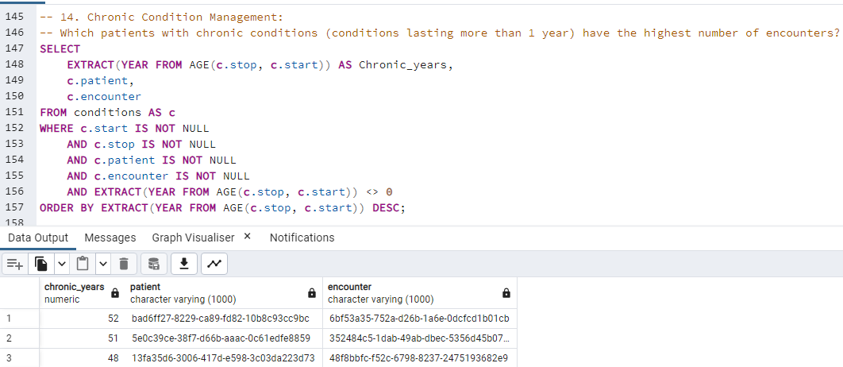

1. **Patient Coverage Gaps:** Identify patients with high healthcare expenses but low healthcare coverage.

